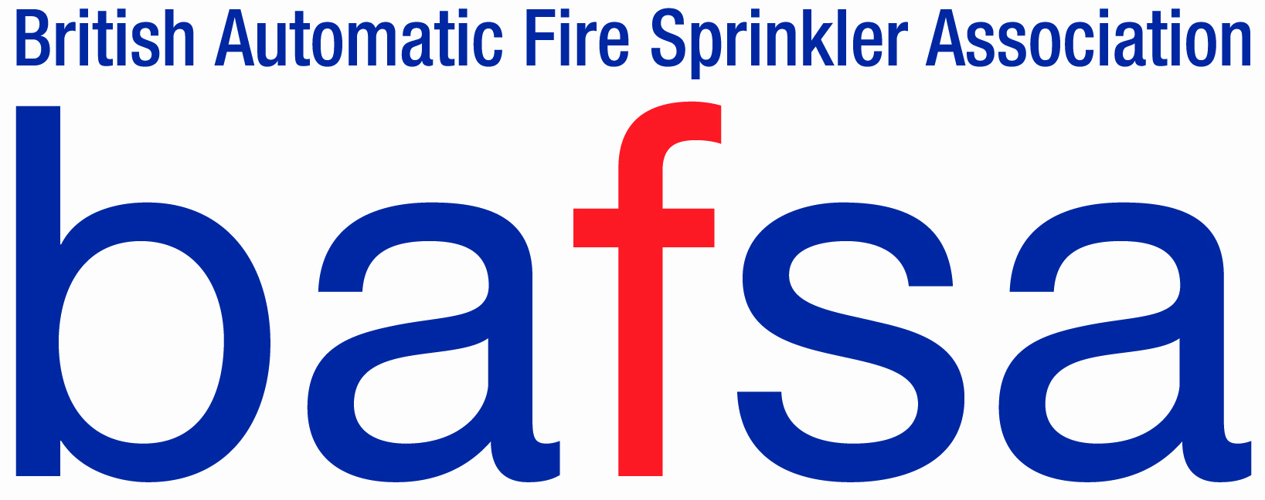 | Application Form
 | Fire Sprinkler Systems
 | Training Course Applied For :
Insert Digital Photograph here
The application form should be completed by the candidate, only applicant with the relevant experience shall be given access to certain courses.

Name:
Email Address

Personal Email Address :
For ABBE Requirements

Personal Contact No:
For ABBE Requirements

Candidate No
(If known)

Company:
Company Address:
Personal Address
For SQA Requirements

Education:

Further Education:

Job Related Qualifications:

Sprinkler Experience:

Sprinkler
Design
Experience:
Health and Safety training *
Additional Support Needs

- Relevant Health and safety certificates should be included within the application.
- A full CV should be issued with the application form.
- One reference

Please note the Inspection and commissioning course requires a minimum of 3 years industry experience before a full certificate can be issued (depending on the outcome of the exam and assessments), Attendance certificates shall be issued to people with less than 3 years.

Payment terms

Once the applicant has been accepted an Order No for the course amount is to be raised, this will then be invoiced for.

The course is to be paid 2 weeks before attending the course, non-payment may result in an applicant being turned away.

Cancellation Charges

Up to 2 weeks - Full Refund
Up to 1 weeks - 80% refund
Up to 3 Days - 20% Refund
No Show - 0% Refund

